Stack and Queue

# Stack

Stack is a linear data structure that follows a particular order in which the operations are performed. The order is that the last inserted element is popped out first [lifo].

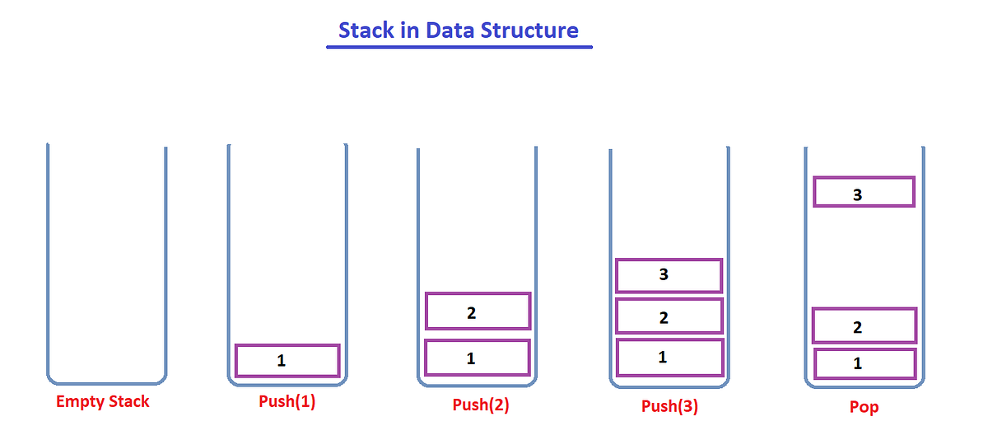

**Top:** The last inserted element in stack. It is imagined to exist at the topmost position of the stack.

**Seek:** The process of displaying the top element

**Push:** insert the element to the top of stack

**Pop:** Remove element from top of stack

We can use list as stack in python. We can use stack[-1] to seek the top element, append() to push and pop() to pop. But a problem with list is that it doesnot help us create static stack, with a specified number of elements. We can use **collections.deque** to implement static stack.

# Queue

It is also a linear datastructure, but it follows LIFO principle. It has a front(removed) and a rear(inserted) .

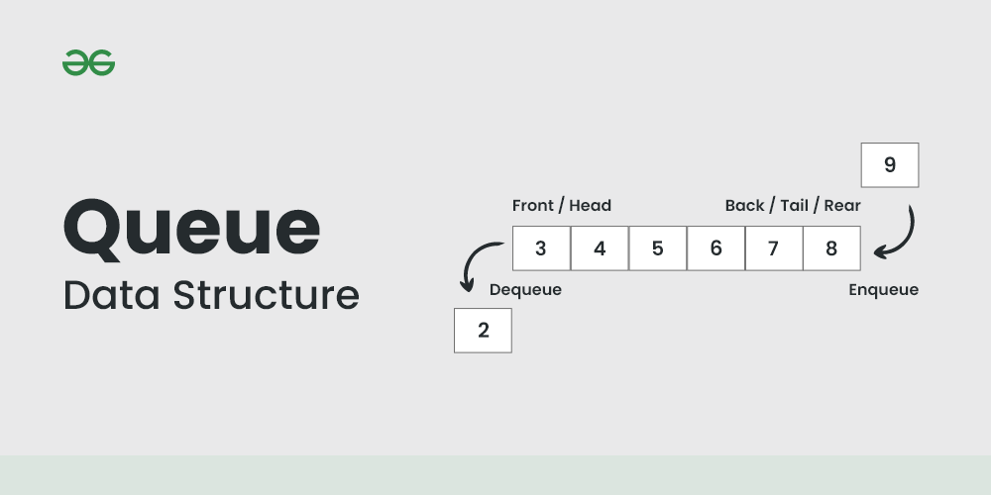

#### Properties:

**Enqueue**: Insert at one end

**Dequeue:** Pop from other end

Varients:

Circular Queue